# Informações do estudo

Referência: Chinchanikar 45

Grandeza: Força

Tipo: Fy

Material: AISI 4340 (45 HRC)

Ferramenta: KC9110

Número de experimentos: 20

Observações:  
Tool holder: PCBNR 2020K12  
Diameter: 90 mm  
Piezo-electric dynamometer: KISTLER Type 9257A  
Surface roughness tester: Qualitest TR100

# Unidades

Velocidade: m/min

Avanço: mm/rev

Profundidade de corte: mm

Força: N

# Dados de teste

|  |  |  |  |
| --- | --- | --- | --- |
| Força | n | f | a |
| 559.0 | 125.0 | 0.25 | 2.0 |
| 296.0 | 125.0 | 0.15 | 1.0 |
| 564.0 | 150.0 | 0.2 | 2.5 |
| 386.0 | 150.0 | 0.2 | 1.5 |

# Dados de treino

|  |  |  |  |
| --- | --- | --- | --- |
| Força | n | f | a |
| 405.0 | 175.0 | 0.25 | 1.0 |
| 506.0 | 150.0 | 0.3 | 1.5 |
| 383.0 | 150.0 | 0.2 | 1.5 |
| 413.0 | 150.0 | 0.2 | 1.5 |
| 377.0 | 150.0 | 0.2 | 1.5 |
| 314.0 | 150.0 | 0.1 | 1.5 |
| 377.0 | 150.0 | 0.2 | 1.5 |
| 433.0 | 125.0 | 0.15 | 2.0 |
| 397.0 | 200.0 | 0.2 | 1.5 |
| 383.0 | 150.0 | 0.2 | 1.5 |
| 492.0 | 175.0 | 0.25 | 2.0 |
| 407.0 | 175.0 | 0.15 | 2.0 |
| 328.0 | 175.0 | 0.15 | 1.0 |
| 256.0 | 150.0 | 0.2 | 0.5 |
| 445.0 | 100.0 | 0.2 | 1.5 |
| 411.0 | 125.0 | 0.25 | 1.0 |

# RN

Número de neurônios: 58

Taxa de aprendizado: 1.000000e-02

Número de épocas: 382

2° camada: True

Função de ativação: tanh

# Erros

**Dados de teste**

* Erro relativo médio: 2.68
* Coeficiente de correlação: 0.99
* Coeficiente de determinação: 0.98
* MSE: 622.27
* RMSE: 24.95

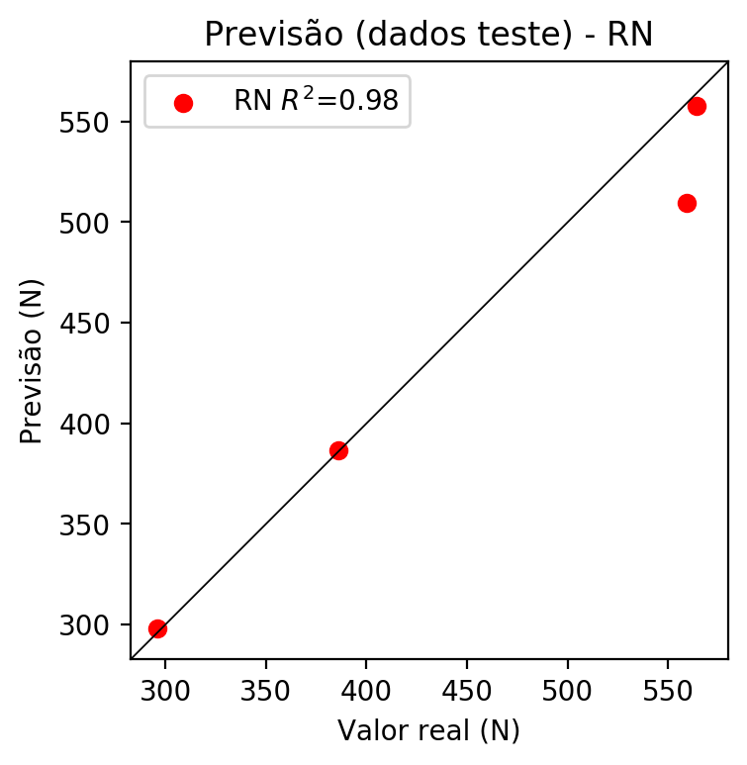

**Dados de treino**

* Erro relativo médio: 0.84
* Coeficiente de correlação: 0.99
* Coeficiente de determinação: 0.98
* MSE: 56.7
* RMSE: 7.53

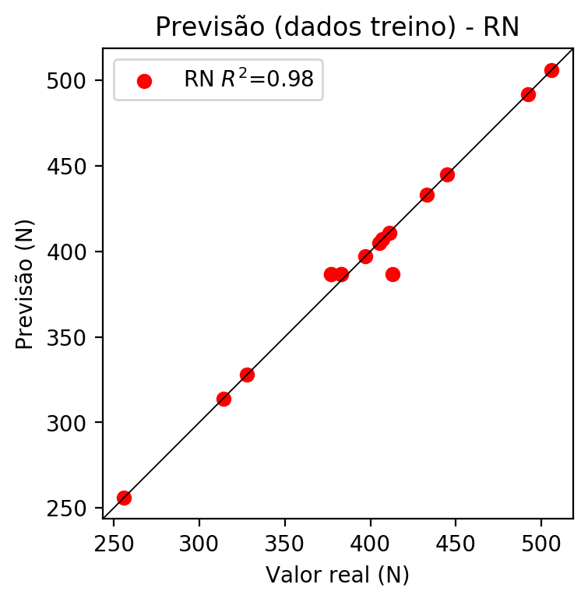

# Pesos

Pesos - camada oculta 1

[[ 0.2031302 0.11657383 -0.35209408 -0.03044252 0.18891542 -0.13970828  
 -0.02899258 -0.03398764 -0.1265725 0.20974274 -0.5256338 0.23738597  
 0.11822807 0.00877926 -0.06047061 -0.3144554 0.24400945 -0.11071556  
 -0.31728128 0.48031843 0.35269088 0.2862238 -0.0234766 0.19419745  
 -0.03925668 -0.36368346 0.36132267 0.17481728 0.24010938 -0.22269046  
 -0.12792467 -0.41046792 -0.13401994 -0.47661483 0.06911377 -0.20768513  
 0.14827386 0.19367498 -0.32800174 -0.2645571 0.26011467 0.16734135  
 0.3244625 0.27105182 0.06518946 0.05072246 -0.00250709 -0.22366132  
 0.30982926 0.39489487 0.30653837 0.3618858 0.06086145 -0.08563081  
 -0.21854885 0.19975875 0.12425919 0.0396213 ]  
 [-0.27683926 -0.21142519 0.24295107 -0.21191975 -0.27436683 0.05588231  
 0.2656332 -0.20574376 -0.09358697 0.06304672 -0.2234876 -0.19946852  
 -0.08691216 0.01961396 -0.05041078 -0.17954537 0.07191374 -0.18715693  
 0.11929935 0.12120027 0.06902725 -0.01690435 0.19923303 -0.30265903  
 -0.27878886 0.01887594 -0.17262906 0.18889825 0.02564522 -0.29786333  
 -0.22467615 0.26103187 -0.17238973 -0.11391368 -0.26805964 0.05257114  
 -0.15231602 -0.24353348 -0.28773844 0.16515873 0.08064649 -0.203823  
 0.14578132 -0.07598577 0.22696167 -0.18569778 -0.27049887 -0.25308502  
 -0.02791419 -0.17612222 0.03266714 0.1280763 0.04729315 -0.13918926  
 0.26510146 0.17257658 0.10703346 0.27626443]  
 [ 0.08498548 -0.10577513 -0.14968611 -0.119672 0.01605902 -0.2477265  
 0.02848601 -0.0763265 0.27662042 -0.06252801 0.3426917 -0.12366141  
 -0.2549424 -0.11624138 0.11764651 -0.00270904 -0.11911178 0.05182179  
 0.2682946 0.04673888 -0.14657766 0.11981641 -0.20702386 0.22495826  
 -0.1348938 -0.18631479 0.00862875 -0.2020053 0.06138173 -0.13456321  
 0.3094646 0.20661986 0.15887973 0.1405921 0.33120808 -0.25354382  
 0.02426253 -0.24843362 -0.17531723 -0.22346075 0.15344352 0.22685727  
 0.14787307 -0.03141889 -0.16155902 0.15823223 -0.20398517 -0.06128577  
 -0.10895084 -0.30259484 0.10672924 -0.21411961 -0.21986663 -0.05394045  
 -0.04991088 0.13751534 -0.22288392 0.16699886]]

Bias - camada oculta

[-0.07161242 -0.03158198 -0.08202288 -0.01757099 0.06025495 0.14814919  
 -0.02809978 -0.10358608 -0.01195762 0.23292099 -0.27480063 0.03557061  
 0.03152693 -0.01910864 0.10885772 0.0373762 0.22261877 -0.11402071  
 -0.0598644 0.12783203 0.1456321 0.20319828 -0.07734174 -0.10297558  
 -0.03883174 -0.03104757 0.02813247 0.08450825 -0.0565862 0.01763619  
 -0.03994527 -0.14054546 0.06846863 -0.19510606 -0.02927664 0.04208016  
 0.04324807 0.05622642 -0.0092071 0.1238578 0.01718395 0.00045418  
 0.01152635 -0.0248713 0.08744176 -0.05860111 -0.05207862 0.00805064  
 -0.15533476 0.11828889 0.01424905 0.13051131 0.13529868 -0.09011517  
 -0.02063525 0.09198533 0.1612927 0.04077312]

Pesos - camada oculta 2

[[ 0.10957247 0.05116356 -0.10805569 ... 0.05146097 0.01372401  
 0.02792308]  
 [-0.24247253 -0.1991299 0.22445461 ... 0.20161316 0.0482872  
 0.23835228]  
 [ 0.03930306 -0.09756435 -0.09504496 ... 0.13625857 -0.2032487  
 0.14170788]  
 ...  
 [-0.10679029 -0.07964497 -0.18028796 ... -0.16238937 -0.14913362  
 0.1801231 ]  
 [ 0.17613205 0.16578224 0.10822465 ... -0.07282683 0.12984376  
 0.15268278]  
 [ 0.1780038 0.11093024 -0.0145794 ... 0.08616683 0.05937029  
 -0.12022825]]

Bias - camada oculta 2

[ 0.00572503 -0.01256876 0.05878872 0.04650276 0.0039118 -0.02988099  
 -0.05363701 -0.00743451 -0.0169836 0.0471857 -0.04611358 0.06328505  
 0.04124741 -0.0232584 0.00379047 -0.04964581 -0.00262603 -0.00864653  
 -0.00251901 0.03619782 0.06227829 -0.08108181 -0.03319553 0.02246564  
 -0.01740637 0.10720194 0.01191925 0.05448754 -0.00628683 0.04542534  
 0.00505301 -0.07438879 0.03523614 -0.02894498 0.02640519 0.06082387  
 0.00559143 0.01689858 -0.04953791 0.02167826 0.02968666 0.0401661  
 0.05046209 0.04499687 0.01318787 0.0082346 0.01938045 0.01171678  
 -0.07932931 -0.0322368 -0.09617956 0.04704671 0.00172857 -0.03570913  
 -0.05533095 0.02498583 0.01094383 0.03897924]

Pesos - camada saída

[[ 2.01633662e-01 4.24664319e-02 -2.14773893e-01 1.28226066e-02  
 1.71648771e-01 -8.71716142e-02 -1.55105423e-02 -9.41794552e-03  
 6.15965691e-04 7.56805316e-02 -2.62623966e-01 1.54830962e-01  
 4.56513353e-02 -1.02742426e-02 -9.96583477e-02 -4.38889861e-02  
 6.06601350e-02 -2.41048634e-02 -1.83444068e-01 1.08114824e-01  
 1.91763297e-01 2.39367470e-01 -5.78800999e-02 5.93555123e-02  
 8.87114182e-03 -2.35898823e-01 3.01659852e-01 4.94803637e-02  
 2.20574185e-01 -2.25054085e-01 -5.72135299e-03 -2.97504574e-01  
 -1.65805832e-01 -1.54493272e-01 -1.81753712e-03 -1.81455940e-01  
 9.88426991e-03 2.89621204e-03 -1.70176327e-01 1.78926028e-02  
 1.42044470e-01 7.82279000e-02 1.67012334e-01 2.07434148e-01  
 8.05511773e-02 1.08324094e-02 -1.83841097e-04 -1.03435375e-01  
 2.53838420e-01 2.68929839e-01 1.80916369e-01 1.02476984e-01  
 -2.77679088e-03 -1.90986525e-02 -1.01143651e-01 6.31070137e-02  
 -9.14577674e-03 8.05655494e-03]]

# Iterações

|  |  |  |  |  |  |  |
| --- | --- | --- | --- | --- | --- | --- |
| Média | Desvio | n | ln | 2° camada | Função | Épocas |
| -0.2025 | 0.0467 | 10 | 0.1 | False | relu | 38 |
| -0.2065 | 0.1488 | 17 | 0.1 | True | relu | 716 |
| -0.2684 | 0.168 | 7 | 0.01 | True | tanh | 130 |
| -0.2356 | 0.2645 | 19 | 0.001 | False | tanh | 282 |
| -0.2108 | 0.1192 | 29 | 0.001 | False | relu | 469 |
| -0.2268 | 0.1575 | 88 | 0.1 | False | tanh | 926 |
| -0.2782 | 0.2288 | 95 | 0.0001 | True | relu | 984 |
| -0.1985 | 0.1933 | 10 | 0.01 | True | tanh | 865 |
| -0.409 | 0.2466 | 58 | 0.001 | True | relu | 8 |
| -0.2621 | 0.1597 | 9 | 0.01 | False | tanh | 514 |
| -0.1714 | 0.0974 | 73 | 0.0001 | True | relu | 729 |
| -0.3837 | 0.5109 | 22 | 0.001 | True | relu | 543 |
| -0.2979 | 0.2338 | 25 | 0.1 | True | relu | 562 |
| -0.2203 | 0.1213 | 53 | 0.001 | False | relu | 498 |
| -0.3348 | 0.3796 | 83 | 0.01 | True | relu | 337 |
| -0.2247 | 0.2393 | 99 | 0.01 | False | tanh | 16 |
| -0.2522 | 0.0908 | 23 | 0.01 | False | relu | 472 |
| -0.3027 | 0.3587 | 24 | 0.001 | True | relu | 778 |
| -0.1532 | 0.0829 | 58 | 0.01 | True | tanh | 382 |
| -0.3635 | 0.2863 | 35 | 0.1 | False | tanh | 596 |

# RL

# Coeficientes

[ 0. -0.09491586 0.52596752 0.66219902]

# Erros

**Dados de teste**

* Erro relativo médio: 6.21
* Coeficiente de correlação: 0.99
* Coeficiente de determinação: 0.99
* MSE: 1119.42
* RMSE: 33.46

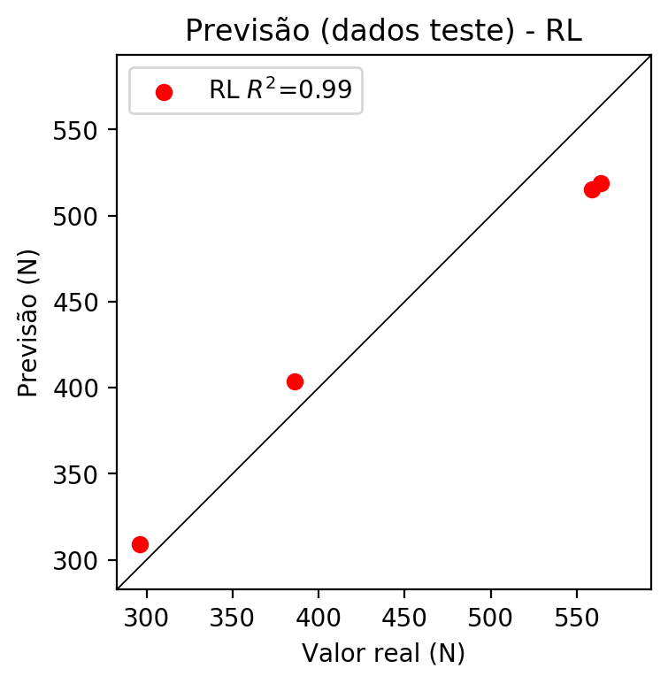

**Dados de treino**

* Erro relativo médio: 4.57
* Coeficiente de correlação: 0.94
* Coeficiente de determinação: 0.89
* MSE: 390.79
* RMSE: 19.77

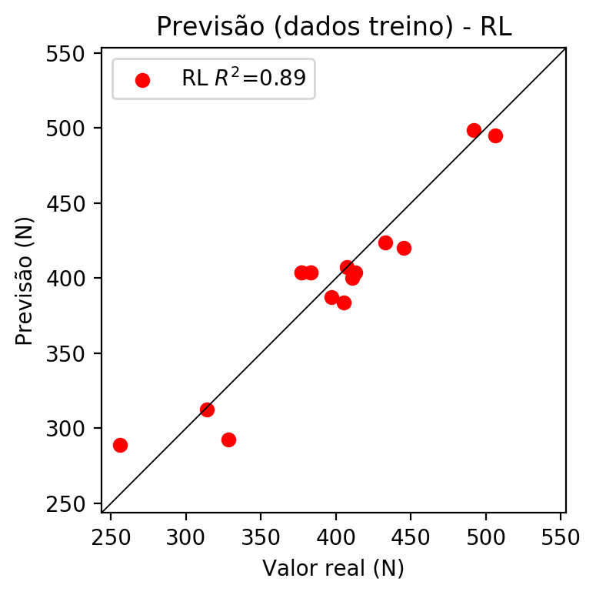

# RP2

# Coeficientes

[ 0. -0.09897376 0.58914513 0.73017727 0.10084934 -0.14528419  
 -0.19816493 0.07176493 -0.00872156 0.01610231]

# Erros

**Dados de teste**

* Erro relativo médio: 4.57
* Coeficiente de correlação: 0.99
* Coeficiente de determinação: 0.97
* MSE: 646.76
* RMSE: 25.43

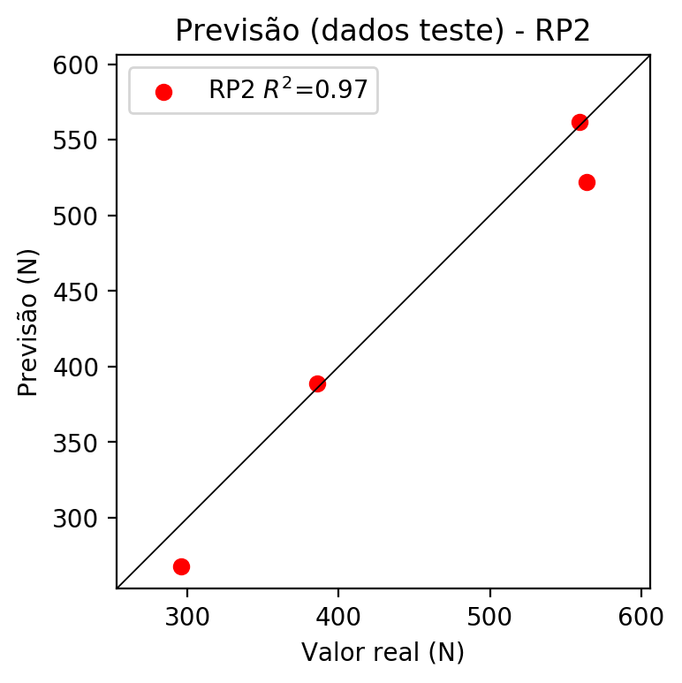

**Dados de treino**

* Erro relativo médio: 2.43
* Coeficiente de correlação: 0.98
* Coeficiente de determinação: 0.96
* MSE: 127.73
* RMSE: 11.3

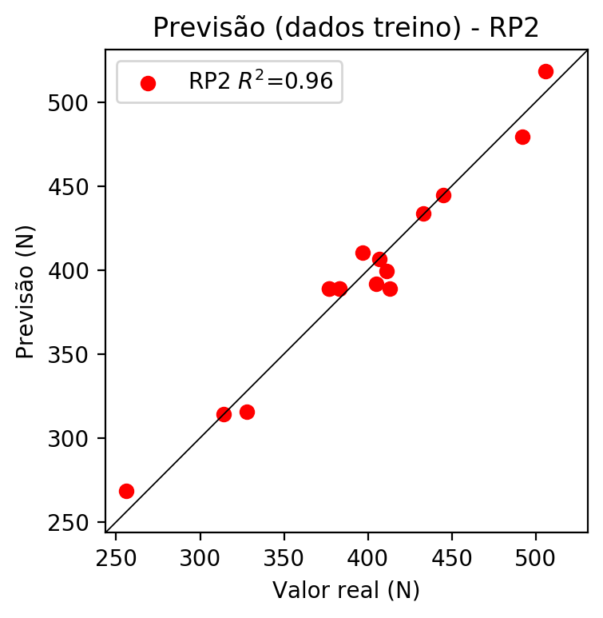

# RP3

# Coeficientes

[-6.93889390e-18 9.70489913e-04 6.90394747e-02 7.71686795e-02  
 9.09548732e-02 8.97129433e-02 3.68322031e-02 6.18704660e-02  
 -5.70460694e-02 7.99150478e-02 -2.93203308e-02 7.53360207e-02  
 6.25633556e-02 1.13100526e-02 7.17597416e-02 1.13100526e-02  
 1.01929442e-01 6.25633556e-02 7.53360207e-02 1.78861161e-01]

# Erros

**Dados de teste**

* Erro relativo médio: 8.89
* Coeficiente de correlação: 0.88
* Coeficiente de determinação: 0.78
* MSE: 3225.64
* RMSE: 56.79

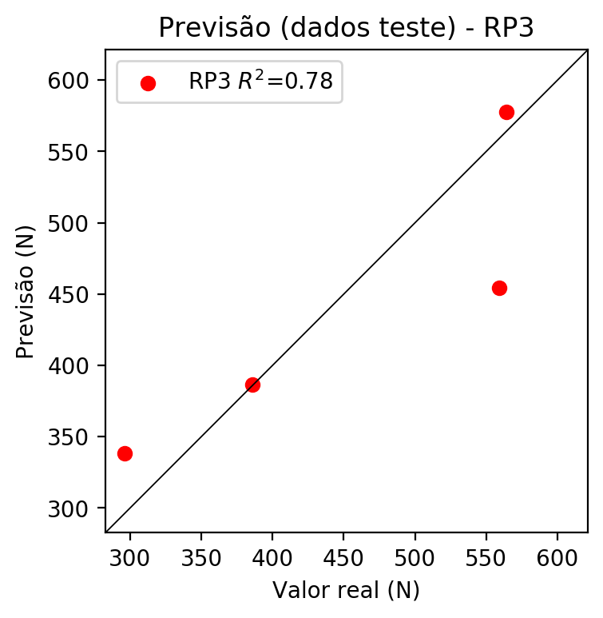

**Dados de treino**

* Erro relativo médio: 0.84
* Coeficiente de correlação: 0.99
* Coeficiente de determinação: 0.98
* MSE: 56.7
* RMSE: 7.53

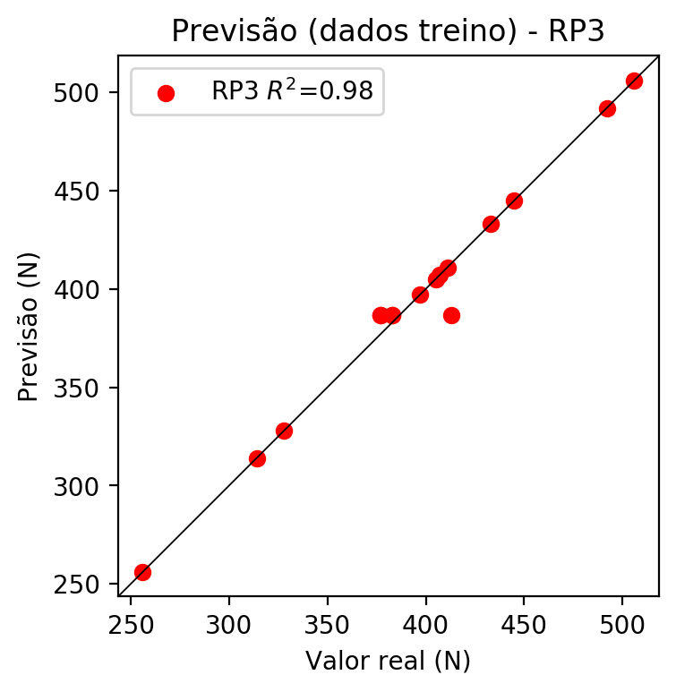

# RP4

# Coeficientes

[-2.77555756e-17 -6.36095208e-03 3.87288159e-02 5.45314628e-02  
 3.50991378e-02 4.20241240e-02 3.19139899e-02 3.38647863e-02  
 -4.89050294e-03 2.62441496e-02 -2.77768694e-02 2.52170806e-02  
 5.53551111e-02 -8.12551005e-04 4.28841499e-02 -8.12551005e-04  
 1.08310634e-01 5.53551111e-02 2.52170806e-02 9.29591150e-02  
 1.17591022e-02 4.99036472e-02 3.78978630e-02 5.16539342e-02  
 -5.80747224e-03 5.16539342e-02 4.99036472e-02 3.78978630e-02  
 4.99036472e-02 3.78978630e-02 5.89593257e-03 -5.80747224e-03  
 5.16539342e-02 -5.80747224e-03 -3.03020922e-02]

# Erros

**Dados de teste**

* Erro relativo médio: 21.14
* Coeficiente de correlação: 0.82
* Coeficiente de determinação: 0.67
* MSE: 12315.37
* RMSE: 110.97

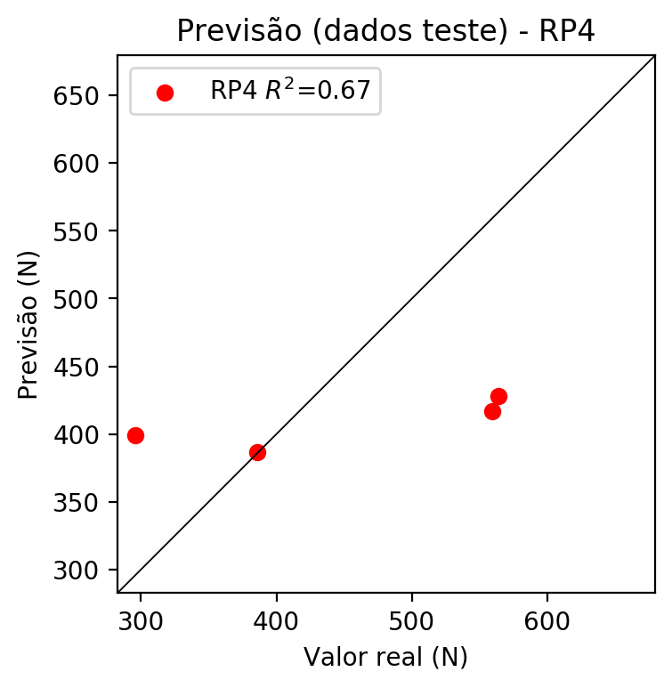

**Dados de treino**

* Erro relativo médio: 0.84
* Coeficiente de correlação: 0.99
* Coeficiente de determinação: 0.98
* MSE: 56.7
* RMSE: 7.53

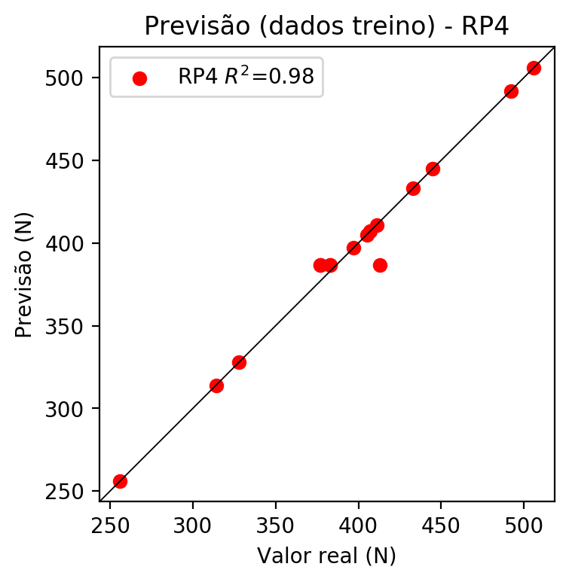

# Geral

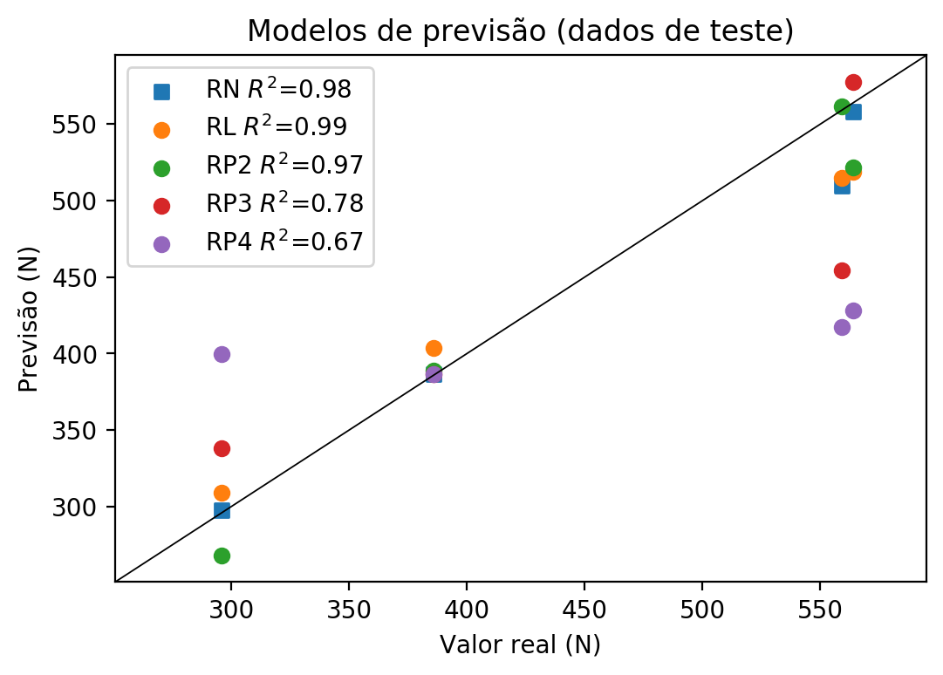

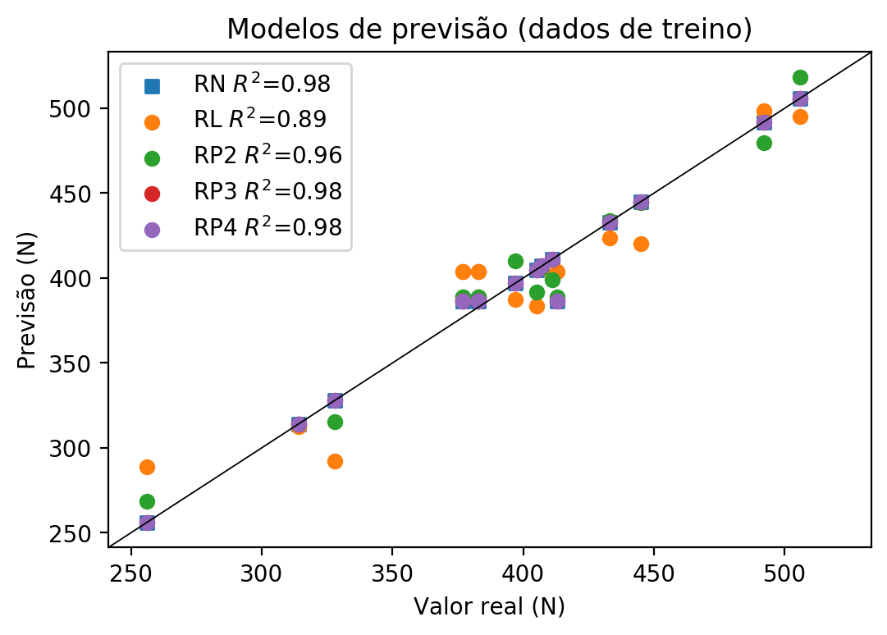

**Dados de teste**

|  |  |  |  |  |  |  |  |  |  |  |
| --- | --- | --- | --- | --- | --- | --- | --- | --- | --- | --- |
| Valor real | RN Previsto | RN Erro (%) | RL Previsto | RL Erro (%) | RP2 Previsto | RP2 Erro (%) | RP3 Previsto | RP3 Erro (%) | RP4 Previsto | RP4 Erro (%) |
| 559.0 | 509.53 | 8.85 | 514.98 | 7.87 | 561.65 | 0.47 | 454.49 | 18.7 | 417.19 | 25.37 |
| 296.0 | 297.9 | 0.64 | 308.79 | 4.32 | 267.75 | 9.54 | 338.35 | 14.31 | 399.46 | 34.95 |
| 564.0 | 557.85 | 1.09 | 518.56 | 8.06 | 521.9 | 7.46 | 577.65 | 2.42 | 428.18 | 24.08 |
| 386.0 | 386.6 | 0.16 | 403.65 | 4.57 | 389.09 | 0.8 | 386.6 | 0.16 | 386.6 | 0.16 |

**Dados de treino**

|  |  |  |  |  |  |  |  |  |  |  |
| --- | --- | --- | --- | --- | --- | --- | --- | --- | --- | --- |
| Valor real | RN Previsto | RN Erro (%) | RL Previsto | RL Erro (%) | RP2 Previsto | RP2 Erro (%) | RP3 Previsto | RP3 Erro (%) | RP4 Previsto | RP4 Erro (%) |
| 405.0 | 405.0 | 0.0 | 383.59 | 5.29 | 391.94 | 3.22 | 405.0 | 0.0 | 405.0 | 0.0 |
| 506.0 | 506.0 | 0.0 | 494.92 | 2.19 | 518.47 | 2.46 | 506.0 | 0.0 | 506.0 | 0.0 |
| 383.0 | 386.6 | 0.94 | 403.65 | 5.39 | 389.09 | 1.59 | 386.6 | 0.94 | 386.6 | 0.94 |
| 413.0 | 386.6 | 6.39 | 403.65 | 2.26 | 389.09 | 5.79 | 386.6 | 6.39 | 386.6 | 6.39 |
| 377.0 | 386.6 | 2.55 | 403.65 | 7.07 | 389.09 | 3.21 | 386.6 | 2.55 | 386.6 | 2.55 |
| 314.0 | 314.0 | 0.0 | 312.38 | 0.52 | 314.0 | 0.0 | 314.0 | 0.0 | 314.0 | 0.0 |
| 377.0 | 386.6 | 2.55 | 403.65 | 7.07 | 389.09 | 3.21 | 386.6 | 2.55 | 386.6 | 2.55 |
| 433.0 | 433.0 | 0.0 | 423.71 | 2.15 | 433.59 | 0.14 | 433.0 | 0.0 | 433.0 | 0.0 |
| 397.0 | 397.0 | 0.0 | 387.18 | 2.47 | 410.06 | 3.29 | 397.0 | 0.0 | 397.0 | 0.0 |
| 383.0 | 386.6 | 0.94 | 403.65 | 5.39 | 389.09 | 1.59 | 386.6 | 0.94 | 386.6 | 0.94 |
| 492.0 | 492.0 | 0.0 | 498.51 | 1.32 | 479.53 | 2.53 | 492.0 | 0.0 | 492.0 | 0.0 |
| 407.0 | 407.0 | 0.0 | 407.23 | 0.06 | 406.41 | 0.14 | 407.0 | 0.0 | 407.0 | 0.0 |
| 328.0 | 328.0 | 0.0 | 292.32 | 10.88 | 315.53 | 3.8 | 328.0 | 0.0 | 328.0 | 0.0 |
| 256.0 | 256.0 | 0.0 | 288.73 | 12.79 | 268.47 | 4.87 | 256.0 | 0.0 | 256.0 | 0.0 |
| 445.0 | 445.0 | 0.0 | 420.12 | 5.59 | 444.41 | 0.13 | 445.0 | 0.0 | 445.0 | 0.0 |
| 411.0 | 411.0 | 0.0 | 400.06 | 2.66 | 399.11 | 2.89 | 411.0 | 0.0 | 411.0 | 0.0 |